Best Dating
Photo Tips for
Men

“Be so good that they can’t ignore you.”

Well said, you know how every word that is written above is absolutely true! Online dating is common these days and with so much competition and profiles from all around the world, the impression of your profile photo is the first thing that attracts the attention. I’m sure it’s super frustrating to not find the right match you deserve but you know a good picture and a professional photographer can turn tables for you. I’ve come across many people who are pretty stiff in front of the camera and believe that they aren’t photogenic which makes them even more conscious about themselves.

Are you awkward in front of the camera? Does it make you shy? Does it not let you bring your real self? Do you show your fun side or not? Do you think that you just need to stand there and smile?
Some men doesn’t want to show their face at all and some just pick up pictures from the past which doesn’t look fresh and recent. These are some common mistakes we find on the dating apps. Honestly, me being a photographer believes in capturing shots that reflects your true personality. People are much more interested so see someone who is confident, fun and exciting rather than someone who is very quiet and private.

When I take photos. I try my best to keep the conversations casual and interesting so we can click some candid pictures in between the shots.

You can share your hobbies through your pictures like playing tennis, or making hot coffee. Here are some ideas you can read that can get you better matches on the dating apps.

1. Avoid using group photos.

Many men think that pictures taken with their friends looks attractive to the women visiting their profile but actually that’s not true. Honestly, it doesn’t make you look social and outgoing at all. It’s better to use pictures of yourself rather than giving an another person the idea of who and how your friends are, for instance you are enjoying with your friends at the bar, the women visiting your profile might think that you are a regular drinker but what if you are not? So, the surroundings matter a-lot.
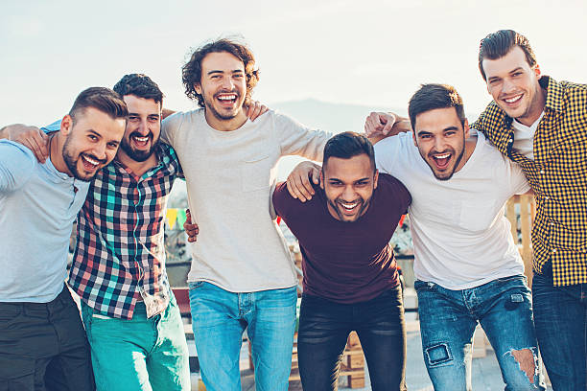

2. Smile that can melt hearts.
Smiling in your pictures shows that you are an easy person to connect with and your match will find you approachable as well. Do things that genuinely makes you happy. You know what's even better? If you can get a laughing shot while enjoying the things that you do!

3. Be creative.
Here, we are talking about your hobbies and your passions. Do you like taking pictures? Playing golf? Reading a book or spending some quality time with your cars and bikes? Click that moment! You can only show your real personality by being yourself. This way you don't seem to look boring to your future match. I love when people have more to show than just their regular work life.

4. The side with your pets ( if you have any)

I'm not lying but nothing looks more adorable to the girls when it comes to a sweet brown dog or a furry little cat. It also shows how good you are with animals.

I really hope you loved reading my tips as much as I loved sharing them with you. These shots are not really hard to take if you try them yourself! But it is a task that can take most of your time and you might end up talking lots of them just to get one right picture.
You can always contact me for your dating profiles. I would love to take these photos for you!
For any questions, you can email me here: hello@elizphotography.com

